**Inter VLAN routing using multi-layer switch**

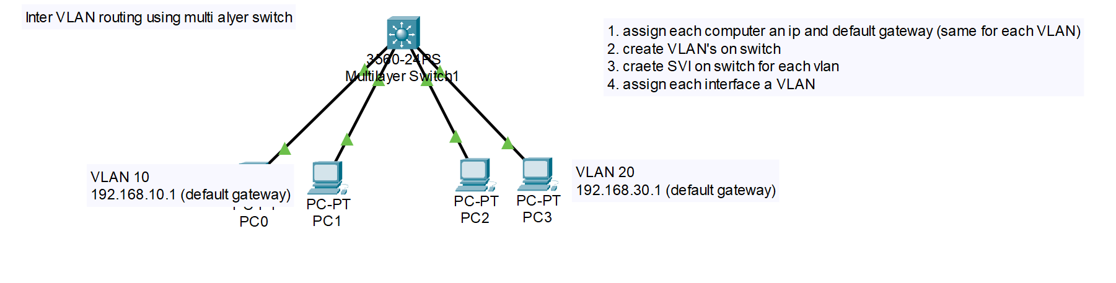

**Task 1: Creating VLAN’s on MLS**

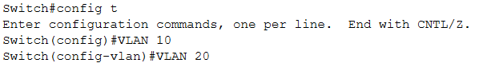

**Task 2: Creating switch virtual interface SVI**

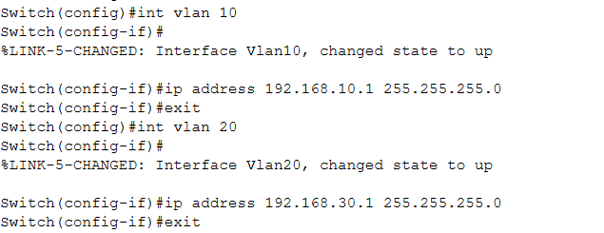

**Task 3: Assigning interfaces to VLAN’s**

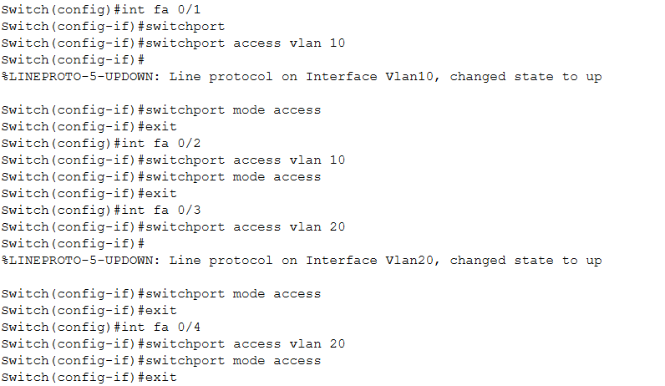

**Task 5: Check VLAN’s**

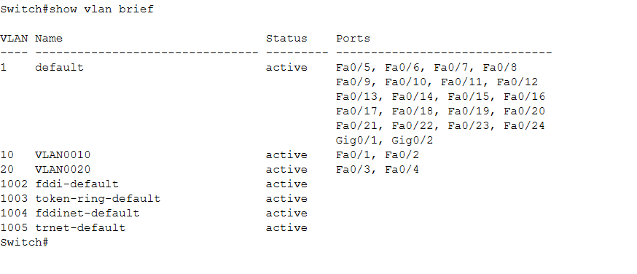

**Task 6: Write configuration**

